# **Avatars from Adelaide-based Clevertar on way as health coaches**

**Adelaide-based artificial intelligence company Clevertar is introducing “Michael” to join “Anna” as health coaches and say the ‘relational agents’ go much further than Siri — just beware the ‘uncanny valley’.**

**Brad Crouch**

**Sunday Mail (SA)**AUGUST 26, 2017**11:59PM**

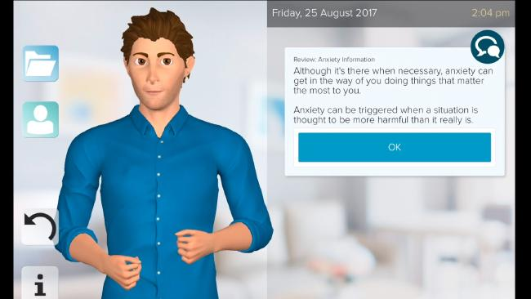

Michael — a digital coach created by Adelaide artificial intelligence firm Clevertar.Source:Supplied

Ads by [Kiosked](http://kiosked.com/" \t "_blank)

MEET Michael — your personal avatar ready to gently coach you to better mental health.

The digital health coach is the first male to join Anna and Laura in the world of virtual health care being pioneered by Adelaide artificial intelligence firm Clevertar, a Flinders University spin-off.

It is a world where you download an app then, in the privacy of your own home and at a time of your choosing, get coached on your tablet or smartphone to cope with health issues.

Laura was used in a closed trial of diabetes management, while Anna has been working to help consumers deal with depression and anxiety issues.

Clevertar decided to expand with Michael to give consumers a wider choice of avatar to make them feel comfortable when talking about delicate issues.

Michael and Anna are now starring in an Australian-first trial targeting more than one million people across Sydney’s west.

Through the app they are combining proven, low-intensity cognitive behaviour therapy programs — developed by mental health clinicians and researchers at Flinders Psychiatry — with 24-hours-a-day free coaching and education services. This comes in addition to face-to-face counselling.

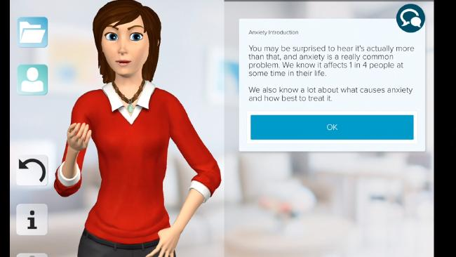

Anna — a digital coache created by Adelaide artificial intelligence firm Clevertar.Source:Supplied

Ads by [Kiosked](http://kiosked.com/" \t "_blank)

Unlike digital assistants such as Apple’s Siri, these avatars will not use voice recognition, which runs the risk of being frustrating for people dealing with mental health issues.

The avatars will talk to the person when discussing issues and working through their goals over several weeks, but the person will respond in the sessions by pressing buttons.

The avatars have been kept looking a little cartoon-like rather than being styled in fully human form.

“If you go too human, you get to the ‘uncanny valley’, where people start not to like them. If they remain cartoon-like, people can relate to it better,” Clevertar chief executive Tanya Newhouse said.

“A lot of research has gone into the look and the voices to make people feel comfortable with them.

“Michael has made history by becoming the first-ever male coach on the Clevertar Digital Coaches platform. He joins Anna to give users greater personalisation and choice.

“It is a coaching program that provides a combination of education and personal goal-setting — it helps people set their goals and never forgets them, and will ask how they are getting on with those goals.

https://i1.wp.com/pixel.tcog.cp1.news.com.au/track/news/content/v2/b3709ba758915d1547e1c32f086bedf4?t_product=newscomau&t_template=../video/player

“They can only do some things — they won’t tell you what to have for dinner — but we are not aware of any other avatars doing what we are doing. Others, like Siri, will have one conversation, but we have conversations that last over weeks as you work towards goals.”

The male and female versions run the same program, so there is no conflicting advice, which may occur when seeing different human coaches.

The Sydney trial is being offered by primary health network WentWest, whose spokesman Bill Campos said: “The use of digital coaches is an exciting frontier of health care. This technology can only get better.”